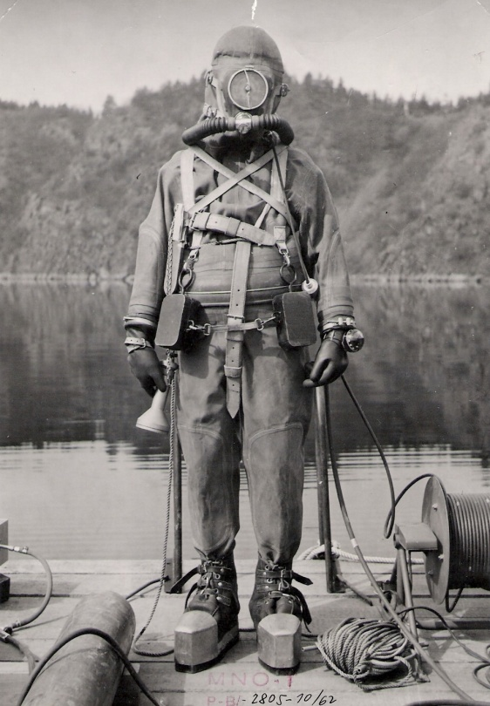

DIVING AND MEETING OF ENTHUSIASTS FOR HISTORICAL DIVING
(4th year of Jiri Trpik Memorial)

Historical Diving Society Czech Republic (HDS CZ) arranges a meeting of members and sympathizers at Diving Base POTYA, 7 – 9 September, 2018

LOCATION: Diving Base POTYA close stone pit Bořená hora - Štětkovice nearby Sedlčany
Website: www.potya.cz

PROGRAM:

Friday, September 7 early arrival of participants – evening informal get-together

Saturday, September 8
9 am – 10 am arrival of participants

10 am – presentation of collections by HDS CZ members; historical diving gear bazaar – sale and exchange of diving UW equipment, books, journals, and other related stuff

11 am – individual diving with historical or up today devices (the HDS CZ does not lend any historical devices and takes no responsibility for devices that will be used by individual owners)

1 pm – presentation and diving with historical diving suits and aqualungs
5 pm – get-together with screening of historical footages of diving gear and presentations on history of diving

7 pm end of the official program

8 pm dinner party (barbecue) organized and covered by HDS CZ to celebrate its 10th anniversary for HDS CZ members and invited guests

Sunday, September 9

free program – individual diving with historical or up today devices, swimming and other water sports (for those interested there is a change to visit an old cars museum in a nearby village Strnadice)
departure

ACCOMODATION:
Accommodation at the Diving Base POTYA:
- 10 three beds bungalows (take sleeping bags and pillows with you)
- 5 two beds bungalows (take sleeping bags and pillows with you)
- One’s own tent or caravan
Parking places for guests are at the base.
Note: Actual information about the accommodation at the base and prices can be found at www.potya.cz. For booking, please, contact Mr. Daniel Ryl (+420 603 265 976) or Mr. Oldřich Lukš (oluks@seznam.cz).

Accommodation in Sedlčany (a town around 6 KM away from the base):
- Hotel Florian
hotelflorian.sedlcany@email.cz
www.ravelguide.cz/florian
tel.: +420 318822207

We are looking forward to meeting you!

Dipl. Ing. Oldřich Lukš Mr Jaroslav Klepal
Chairman of HDS CZ Administrator of HDS CZ

